
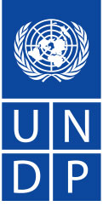


Project Document
Government of Namibia

United Nations Development Programme

Global Environment Facility

Medium Size project:
Enhancing Institutional and Human Resource Capacity through Local Level Coordination of Integrated Rangeland Management and Support (CALLC)

Under the
Country Pilot Partnership framework for Integrated Sustainable Land Management (CPP-ISLM)
Project Brief The government of Namibia has identified land degradation as a serious problem which demands remedial intervention. It has recognised that integrated sustainable land management strategies are needed to effectively address the underlying causes. Existing efforts on-the-ground are obstructed by a series of barriers, which undermine their efficacy. Although the government has been, and remains, fully committed to combating land degradation, insufficient capacity at systemic, institutional and individual levels, and inadequate knowledge and technology dissemmination are constraining the effectiveness of interventions and the sustainability of outcomes.
Five Ministries, namely the Ministry of Agriculture, Water and Forestry, Ministry of Environment and Tourism, Ministry of Lands and Resettlement, Ministry of Regional and Local Government and Housing and Rural Development, and the National Planning Commission - have agreed in conjunction with the GEF and its Implementing Agencies, the European Union, GTZ and NGO community to overcome these barriers through a Country Pilot Partnership for Integrated Sustainable Land Management (CPP). The CPP comprises a suite of interventions to address the underlying causes of land degradation in Namibia.

Enhancing Institutional and Human Resource Capacity through Local Level Coordination of Integrated Rangeland Management and Support (CALLC) is one of the suites of projects under the Namibia CPP programme. It will specifically contribute to Objective 2 of the CPP; identifying and disseminating cost-effective, innovative and appropriate SLM techniques which integrate environmental and economic benefits. The CALLC project intervention will be implemented in North Central Namibia (Ohangwena, Omusati, Oshana and Oshikoto Regions). These regions represent four of Namibia’s five most densely populated regions with more than 13 people/ sq km. 83% of the area in the four regions is at moderate to high risk of degradation.

Factors causing this situation include deforestation, overstocking and overgrazing, naturally high rainfall variability, limited awareness of carrying capacities of the land and high levels of poverty which place heavy dependence on natural resources. On top of these factors, is an absence of strong community-based institutions; the presence of strong cultural values placed on livestock; and the absence of alternatives for capital accumulation. CALLC will build and strengthen institutional environment for SLM and test ways and means for organizing communities to spearhead community-based SLM activities. CALLC will help to demonstrate that strengthened institutional capacity at local level is necessary for sustainable land management. CALLC will also seek to identify opportunities for local economic development compatible with SLM objectives, helping to make the economic and financial case for investment by the private sector, and development banks at local level. This is expected to improve the opportunities for investments in land use diversification, as needed to reduce the impetus for current land uses that are placing pressure on the functional integrity of dryland environments.

-------------

TABLE OF CONTENTS

Section I: The Narrative 3
Preface: the Namibia Country Pilot Partnership (CPP) Framework 3
Part I - Situation Analysis 1
Part II – Strategy 2
Fit with GEF Strategic Priorities 2
Global and national benefits 2
Project design 4
Part II – CALLC Project Linkages 5
Sustainability and replicability 6
Part III - Management Arrangements 7
Project Implementation Arrangements 8
Part IV - Monitoring and Evaluation Plan and Budget 1
Part V - Legal Context 3
1.1.1. Audit clause 4
Section II: Strategic and Resources Framework 5
SECTION III: TOTAL BUDGET AND WORKPLAN 12
Other Financial Modalities – CPP Overall Project Financial Modalities 14
Incremental Cost Analysis 15
1.1.2. National Development Objectives 15
Global Environmental Objectives 16
System Boundary 16
SECTION IV: ADDITIONAL INFORMATION 17
Part I: Approved MSP 17
Letters of Endorsement 17
Part III: Terms of Reference for key Project Staff and main sub-contracts 21
Project Management Unit for the project: 21
Project Coordinator (PC) 22
Senior Technical Advisor: 23
Field coordinators/facilitators (FCs) - 4 24
Project Office Assistant 25
Signature Page 27

List of Acronyms

ADC | Agriculture Development Centre
Agra | Agra Co-op (Pty) Ltd, an agricultural service company
AET | Agricultural Extension Technician
AIDS | Acquired Immune Deficiency Syndrome
AU | Africa Union
BIOTA | Biodiversity Transect across southern Africa
CALLC | Enhancing Institutional and Human Resource Capacity through Local Level Coordination of Integrated Rangeland Management and Support
CBNRM | Community Based Natural Resources Management
CBOs | Community Based Organizations
CEDAW | Convention on the Elimination of all forms of Discrimination Against Women
CPP | Country Pilot Partnership for Integrated Sustainable Management
CPP ISLM | Country Pilot Partnership for Integrated Sustainable Management
CPAP | Country Programme Action Plan
CRIAA | Centre for Research Information Action in Africa
DEES | Directorate of Engineering and Extension Services
DoF | Directorate of Forestry
DRFN | Desert Research Foundation of Namibia
DRWS | Directorate of Rural Water Supply
DVS | Directorate of Veterinary Services
DWA | Department of Water Affairs
EIA | Environmental Impact Assessment
EU | European Union
FED | Farmer’s extension districts
FIRM | Forum for Integrated Resources Management
GEF | Global Environment Facility
GRN | Government of the Republic of Namibia
GTZ | Deutsche Gesellschaft für Technische Zusammenarbeit (German Agency for Technical Cooperation)
HDI | Human Development Indices
HIV | Human Immunodeficiency Virus
HPI | Human Poverty Indices
IAs | Implementing Agencies
ILTER | International Long-Term Ecological Research
ISLM | Integrated Sustainable Land Management
IWRM | Integrated Water Resources Management
LLM | Local Level Monitoring
M&E | Monitoring and Evaluation
M&E&A | Monitoring and Evaluation and Adjustment
MAWF | Ministry of Agriculture, Water and Forestry
MDGs | Millennium Development Goals
Meatco | Meatco, an abattoir and tannery company
MET | Ministry of Environment and Tourism
MLR | Ministry of Lands
MRLGHRD | Ministry of Regional and Local Government and Housing and Rural Development
MSP | Medium Sized Project proposal
MYFF | Multi-Year Funding Framework
NAP | National Action Programme
NAPCOD | Namibia’s Programme to Combat Desertification
NCSA | National Capacity Self Assessment
NEPAD | New Partnership for Africa’s Development
NGO | Non Governmental Organization
NNF | Namibia Nature Foundation
NPC | National Planning Commission (GRN)
NPRAP | National Poverty Reduction Action Programme
NRM | natural resource(s) management
OLDeP | Oshikoto Livestock Development Programme
OP | Operational Programme
PESILUP | Promoting Environmental Sustainability through Improved Land Use Planning
RRF | Results and Resource Framework
SADC | Southern African Development Community
SLM | Sustainable Land Management
SP | Strategic Priorities
ToR | Terms of Reference
UNCBD | United Nations Convention on Biological Diversity
UNCCD | Nations Convention to Combat Desertification
UNDAF | United Nations Development Assistance Framework
UNDP | United Nations Development Programme
UNFCCC | UN Framework Convention on Climate Change
UNV | United Nations Volunteers
WAD | Women’s Action for Development
WPC | Water Point Committee

Section I: The Narrative

- CALLC is part of the Namibia CPP (figure 1). The Preface below further clarifies the linkage of CALLC to the CPP.

Preface: the Namibia Country Pilot Partnership (CPP) Framework

- The government in conjunction with the GEF and its Implementing Agencies, the European Union, GTZ and NGO community have agreed to overcome barriers to land degradation through a Country Pilot Partnership for Integrated Sustainable Land Management (CPP) Programme. The Namibia Country Pilot Partnership (CPP) (figure 1) is a government driven programme which will include five categories of projects, outlined below:
- Category 1: Four project components directly funded by GEF in this Phase One CPP process.
- Category 2: Two regional GEF-UNEP projects which have Namibia components.
- Category 3: The fully-agreed co-financed interventions from Government and donor (e.g. EU). To this will be added further investments currently under discussion in Namibia, including for example, projects from GTZ and France.
- Category 4: Parallel initiatives, some by GEF, some by other partners, which seek similar goals of sustainable resource management (e.g. the wildlife and forest sectors, including GEF-UNDP SPAN, and FFEM Conservancies).
- Category 5: Potential investment projects for SLM GEF 4 in Namibia, which build on this CPP framework.

- The four category 1 projects directly funded by GEF are outlined in the table below.
Table 1: Projects under the CPP by agency

Project title | Amount in US dollars | Agency
1. SLM Support and Adaptive Management (CPP NAM SLM SAM) | 7 | UNDP
2. Enhancing Institutional and Human Resource Capacity through Local Level Coordination of Integrated Rangeland Management  and Support (CPP NAM CALLC) (This project) | 1 | UNDP
3. Adapting to Climate Change through the Improvement of  Traditional Crops and Livestock Farming (CPP NAM CCA) | 1 | UNDP
4. Promoting Environmental Sustainability through Improved Land  Use Planning (CPP NAM PESILUP) | 1 | WB

- These projects, the CPP NAM CALLC, CPP NAM CCA and the CPP NAM SLM SAM are implemented by NEX arrangements with Government and NGO involvement. All three are being sent to GEFSEC for CEO clearance at the same time. Project 4 is a World Bank (WB) initiative, also being developed under the CPP umbrella, due to be completed in coming weeks. Project B1 – SLM SAM (previously referred to as the “Umbrella Component”) provides the overarching institutional arrangements and coordination, including monitoring and reporting mechanisms for the CPP, so as to align the components within a programmatic framework.
- The CPP is fully endorsed by Government at all levels, with Permanent Secretaries from Five Ministries and the National Planning Commission providing cross-sectoral programmatic oversight at national and de-centralized levels. The Government considers the CPP as a national framework Programme into which new SLM interventions will be integrated and aligned. Programmatic Integrity is ensured within vertical and horizontal structures as shown in figure 1, by a strong adaptive management and monitoring – evaluation process. Oversight is provided at three levels: at National Governing Body, at the Technical Coordination and at decentralised regional steering committee (details in the Project Arrangements section).
Figure 1: CPP Projects Linkages
Country Partnership Programme (CPP) for Sustainable Land Management Support and Adaptive Management in Namibia
Combat land degradation using integrated cross-sectoral approaches that enable Namibia to reach its MDG #7: “environmental sustainability”, and assure the integrity of dryland ecosystems and ecosystem services. At the programmatic level to build and sustain systemic, institutional and individual capacity, and ensuring cross-sectoral and demand driven coordination and implementation of sustainable land management (SLM) activities.

Other GEF funded projects
CPP
Sustainable Land Management Support and Adaptive Management
USD 7 mill
CCA
Adapting to Climate Change through Improvement of Traditional Crops and Livestock Farming USD 1 mill

CALLC
Enhancing institutional & human resource capacity through local level coordination of integrated rangeland management & Support. USD 1 mill

PESILUP
Promoting Environmental Sustainability through Improved Land Use Planning
USD 1 mill
KNP
Kalahari Namib project: enhance decision-making through interactive learning and action in Molopo-Nossob basin

DMP
Deserts Margin Project: Conservation & restoration of biodiversity in desert margins of Namibia
ICEMA
Integrated Community-based Ecosystem Management
Projects

Management Arrangements (NEX)
MET - EA
WB - IA
With CBNRM partners
Partner Implementing Organisation (PIO)

DRFN- EA
UNEP- IA

Partner Implementing Organisation (PIO)

DRFN- EA
UNEP- IA

Partner Implementing Organisation (PIO)

NNF – EA
WB- IA

Partner Implementing Organisation (PIO)

MAWF - EA
UNDP IA

Partner Implementing Organisation (PIO)

MAWF- EA
UNDP IA

CCA project Management Unit
Omusati

MET- EA
UNDP –IA

CPP Cordination Unit
Windheok
& regions as appropriate

Demonstration Areas

Otjozondjupa & Omaheke Regions
Demonstration Areas

Kavango, Caprivi
Kunene, Omaheke
Otjozondjupa
Karas, Hardap
Demonstration Areas

Omusati Region
Demonstration Areas

Omusati Oshana Oshikoto and Ohangwena Regions
Demonstration Areas

Omusati, Oshana Oshikoto, Ohangwena Kavango, Hardap
Otjozondjupa

Demonstration Areas

Hardap & Omaheke: Nossob – Oub catchments
Pilot sites
to identify cost effective, innovative and appropriate SLM methods which integrate environmental and economic objectives.

to develop and pilot a range of effective coping mechanisms that assist subsistence farmers in Namibia’s North-Central regions to better manage and cope with climate change, including variability such as droughts
to test institutional mechanisms that enable communities working in partnership with key support agencies to develop their goals and manage activities for ISLM &
Cost-effective approaches that build local capabilities to bridge skills gaps for ISLM and livelihood diversification identified and tested

to strengthen local, regional and national level capacity needs for environmentally sustainable land use planning in support of sustainable land management
to support communities in the Molopo-Nossob catchment area to effectively combat desertification and mitigate the effects of drought

to strengthen the capacity of local communities to assess and take measures to prevent land degradation and biodiversity loss in selected pilot areas in the Kalahari & Karoo ecosystems

Objectives
to restore, secure and enhance key
ecosystem processes in targeted conservancies for biodiversity and land conservation and sustainable use

Demonstration Areas

Kunene, Karas
Caprivi, Oshikoto, Otjozondjupa

CPP partner implementing agencies in government: MAWF, MET, MME, MLR, MRLGHRD, NPC together with Civil Society, NGOs and CBOs as partner implementing organisations at national, regional and local levels, and private sector

Part I - Situation Analysis

- The government of Namibia has identified land degradation as a serious problem which demands remedial intervention. It has recognised that integrated sustainable land management strategies are needed to effectively address the underlying causes. Existing efforts on-the-ground are obstructed by a series of barriers, which undermine their efficacy. Although the government has been, and remains, fully committed to combating land degradation, insufficient capacity at systemic, institutional and individual levels, and inadequate knowledge and technology dissemmination are constraining the effectiveness of interventions and the sustainability of outcomes.
- Given the need to continually adapt to new factors and circumstances that influence the state of land and its resources, combating land degradation will be a long-term endeavor. An adequate time budget and sustained investment will be needed to enable resource users and managers to adopt an adaptive management framework that will ensure that barriers and root causes to land degradation, rather than symptoms, are mitigated. Thus, a phased approach is envisaged, with activities split into two phases of 5 years each.
- During the first phase of CPP implementation (2006-2010), GEF activities will be applied to build Namibia’s capacity to absorb investments in combating land degradation. At national level, GEF resources will be dedicated towards building capacity at the systemic, institutional and individual scales to plan, execute and monitor SLM activities. The funding is intended to improve the enabling environment for the pursuit of SLM, an endeavor towards which other funding has been leveraged. At a local-level resource users will be empowered to assess their sustainable land use management options and draw down extension services and support from external service providers according to their particular land management needs. The second phase (2011 – 2015) will focus on leveraging investments to consolidate progress made in phase 1, scale up best practices which have been identified in the first phase and advance state-of-the-art measures to adapt SLM approaches to anticipated long-term climatic changes. These interventions will collectively ensure that land is not just conserved but productively employed, so ensuring the socio-economic durability of SLM beyond the attainment of environmental objectives.
- The CPP embraces a programmatic approach, comprising a suite of linked projects, funded by the GEF, Government of Namibia, European Union, GTZ and UNDP and with provision made to progressively secure additional finance from the private sector. These projects are aligned against a common set of goals, objectives and outcomes, and will be monitored against indicators established at the Programme Level. A coordination framework will be put in place, involving five Ministries, NGOs, academia and donors, to give policy direction, and monitor and take steps to improve the impacts of projects. Goals, Objectives, Outcomes and Outputs for the CPP are elaborated in the CPP document for Phase 1.

- CALLC is contributing to Objective 2 of the CPP framework; identifying and disseminating cost-effective, innovative and appropriate SLM techniques which integrate environmental and economic benefits. Four areas namely; Ohangwena, Omusati, Oshana and Oshikoto Regions in the North Central region have been selected for the CALLC project intervention. These regions support at least 43% of the population in about 10% of the surface area of Namibia. The regions also represent four of Namibia’s five most densely populated regions with more than 13 people/ sq km. 83% of the four regions is at moderate to high risk of degradation.
- Factors causing degradation in these regions include deforestation, overstocking and overgrazing, naturally high rainfall variability, limited awareness of carrying capacities of the land and high levels of poverty which place heavy dependence on natural resources. These factors are compounded by weak community-based institutions, strong cultural values placed on livestock coupled with lack of alternatives for capital accumulation, insecure land tenure, inflexible use of rangelands, and inadequate awareness of decision-making tools to improve flexibility. CALLC will address the identified causes of land degradation in North Central Namibia by building and strengthening institutional environment for SLM and testing ways and means for organizing communities to spearhead community-based SLM activities. CALLC will help to demonstrate that strengthened institutional capacity at local level is necessary for sustainable land management. CALLC will also seek to identify opportunities for local economic development compatible with SLM objectives, helping to make the economic and financial case for investment by the private sector, and development banks at local level. This is expected to improve the opportunities for investments in land use diversification, as needed to reduce the impetus for current land uses that are placing pressure on the functional integrity of dryland environments.

Part II – Strategy

Fit with GEF Strategic Priorities

- The CALLC project, as part of the CPP, conforms to the principles, expected outcomes and strategic directions of GEF Operational Programme 15: Sustainable Land Management. Specifically, it aims at addressing the root causes and effects of land degradation on the functional and structural integrity of dryland environments in Namibia. CALLC will address the key impediments to adoption of integrated sustainable land management practices by: strengthening institutional and human resource capacity for SLM to achieve global benefits within the context of Sustainable Development; strengthening economic incentives to facilitate wider adoption of SLM across production sectors to address multiple (sometimes conflicting) demands on natural resources, and strengthening knowledge management and technology dissemination capabilities in Namibia.

- Furthermore, CALLC addresses both SLM-1 namely: Targeted capacity building, and SLM-2: Implementation of innovative and indigenous sustainable land management practices. SLM-1 is addressed though efforts to address the deficit in systemic capacities for SLM, through mainstreaming of SLM objectives into the national planning framework and sector frameworks and capacity building within key institutions responsible for SLM. SLM-2 is addressed through pilot activities in the field aimed at adapting land practices, and replicating lessons and good management practices.

Global and national benefits

- The project interventions, especially action at a local level, will have cumulative impacts on a global scale in the focal area of land degradation. Land degradation triggers destructive processes that affect the entire biosphere. The project will tackle the major forms of land degradation in the selected pilot regions which are: (i) vegetation degradation which includes rangeland degradation, deforestation and degradation of woodlands, (ii) soil degradation which includes soil erosion and loss of soil fertility.

- The global environmental benefits arising from the maintenance of these ecosystems in North-Central Namibia include: reduced carbon emissions, improved carbon sinking capacities, improved watershed regulation services within transboundary waterways, and reduced stress on biodiversity of global significance and improved air quality and micro-climatic functioning from the maintenance of land cover.

- The intervention areas are situated in the Cuvelai basin, a transboundary ephemeral basin (shared between Angola and Namibia). The Cuvelai basin is significant to the conservation and management of international waters and wetlands. Considering that land degradation impacts on this basin are expected to be severe, preventive and restoration measures that lead to an improvement of ecosystems will trigger benefits that go beyond the borders of Namibia, and generate environmental benefits of global significance.

- At the national level, CALLC will contribute to several actions identified as priorities under the CPP, in line with NAP guidelines. Firstly, it will help identify feasible farming options that will help to diversify the livelihoods of rural communities (Action 19); where applicable this will include the planting of economically valuable trees, ensuring that indigenous tree species are chosen that are suitable to the respective environmental conditions (Action 21); CALLC will test and adapt new ways of providing extension services to poor farmers by extending the FIRM (Forum for Integrated Resource Management) approach and drafting best practice guidelines for extension service providers (Action 23); Local Level Support will abet the identification and evaluation of best practices and models that combine sustainable agricultural practices and poverty reduction (Action 24); it may assist MET in its efforts to scale up conservancies across the country (Action 25); it will enhance the capacity of regional and local authorities with respect to SLM, and will thus support MRLGHRD to enhance the delivery capacity of these authorities (Action 48); and finally, it will support partner Ministries to accelerate the pace of decentralization (Action 49).

- CALLC directly addresses some of the capacity shortcomings identified in the National Capacity Self Assessment (NCSA) as hampering efforts to meet the country’s obligations under the UNCCD, UNFCCC and UNCBD. It will help improve relationships between all stakeholders horizontally (between Government and civil society at national and regional levels respectively) and vertically (between the regional/ local level and national level). The absence of information flow and cooperation at these two levels was identified as a major constraint in the NCSA and a priority to be addressed in follow on interventions. At the institutional level, the CPP will enhance the capacity of partner Ministries and regional authorities to plan, take action, monitor, evaluate and adapt land management support activities. At the individual level, it will build skills within communities to establish alternative livelihoods and to monitor land use impacts. Furthermore, it will pilot and adapt measures to organize communities and strengthen appropriate institutions at community level to spearhead and sustain community-based SLM. As a pilot exercise, it advances community-based monitoring mechanisms through the FIRM approach that allow easy and comprehensible monitoring of natural resources at local level. For the first time, this approach will be piloted in a dynamic socio-economic environment to demonstrate that strengthened institutional capacity at local level is essential for SLM.

- CALCC will be implemented in villages to be selected in north-central Namibia. As in other parts of the country, HIV/AIDS remains the biggest threat in north-central Namibia, with statistics indicating that the prevalence among pregnant women (≥ 13 years) in the regions is about 21.5% (MHSS, 2004). The project, with support from the UNDP HIV/AIDS Programme, will strengthen the capacity of FIRM participants in the selected areas to establish and operationalize a HIV/AIDS community outreach programme focusing on their response to the impacts of HIV/AIDS. The CALCC will therefore take on board views of both women and men during the consultative and community facilitation processes, with the understanding that they contribute to sustainable land management in different ways.

Project design

- Goal: The goal of the project is to improve natural resources based livelihoods, ecosystem stability, functions and services in the Ohangwena, Omusati, Oshana and Oshikoko Regions. Selected local communities, cooperating with a variety of national to local level stakeholders, in four regions will be supported to use and manage their land in a pro-active and sustainable manner, thus contributing to ecosystem stability, functions and services. Lessons learnt will be widely disseminated and uptake of successful activities encouraged in other areas throughout the country.

- Objective: CALLC will contribute to the goal by creating an enabling environment (knowledge, skills, capacity, and policies) for the adoption of sustainable land management and practices in the Ohangwena, Omusati, Oshana and Oshikoko Regions. Two outcomes will collectively achieve the objective and contribute to the goal. They are: Outcome 1: Local level institutional arrangement for effective partnerships in sustainable land management tested and implemented; and, Outcome 2: Knowledge generated and used to support local level SLM and sustainable alternative livelihoods diversification strategies.

- Outcome 1: In a highly variable environment like Namibia, opportunism in land management is essential but is only possible if relevant information is regularly available for pro-active decision-making by the local resource users themselves and their institutions. FIRM (Forum for Integrated Resource Management) is shorthand for an approach that puts rural communities in charge of their own development. A Community-Based Organization (CBO) organizes, plans and monitors development activities while coordinating the interventions of others, called 'service providers' (SO). SOs may be traditional authorities, government extension services, non-governmental organizations (NGOs) or project teams. Outcome one will lead to the establishment of FIRMs in the project areas. FIRMs will enable local communities to be at the centre of their own development process. FIRMs will be platforms where relevant service providers are able to contribute to the development needs of local resource users in a coordinated manner. Capacity will be build for community based organizations (CBOs) through the FIRMs to enable local resource users to independently develop their own land management plans, and to solicit relevant support from external supporters to implement those plans in a sustainable manner. FIRMs will review national and local level policies and the effect on local level natural resources management, identify recommendations that will improve the efficiency and viability of local level resources management for local economic growth and equitable access to benefits. The outputs expected from this outcome are:

- Output 1.1: An awareness strategy on the importance and benefits of FIRMs developed and implemented
- Output 1.2: FIRMs established
- Output 1.3: Capacity of various stakeholders to plan for and implement improved resource management effectively strengthened
- Output 1.4: Policy recommendations for local level policy reform in support of SLM and FIRMS reviewed and/or formulated

- Outcome 2: With guidance from stakeholders represented in the FIRMs, communities will identify alternative land-uses and business opportunities that would support sustainable land management. Examples could be increasing livestock marketing so that farmers can make money while reducing overstocking and overgrazing, or greater commercial marketing of indigenous fruits such as Amarula to reduce the heavy dependence on livestock. Successful enterprises and practices will be tested, demonstrated, and shared locally with decision-makers and other stakeholders to secure local political buy-in and support for up-scaling of best practices. Outputs from this outcome are:

- Output 2.1: Opportunities for profitable, viable and sustainable strategies for diversification of livelihoods identified, tested and piloted;
- Output 2.2: Communities, Government extension officers and private sector entrepreneurs have skills, market outlets and other institutional linkages to exploit alternative livelihoods options to support a sustainable and thriving local level economy;
- Output 2.3: Improved land management practices identified and promoted;
- Output 2.4: An M&E system developed and information collected and used to support adaptive management.

Part II – CALLC Project Linkages

- CALLC is part of the demonstration interventions at the regional and local level within the Namibia CPP (see figure 1). The CPP comprises about seven demonstration interventions based on different models. CALLC addresses one model to be piloted. The linkages between the CALLC project and the CPP are explained throughout the document and clearly demonstrated in figure 1. The two figures below demonstrate further CALCC linkages per CPP objective.

Figure 2: Linkage between CALLC and the other objectives under the CPP

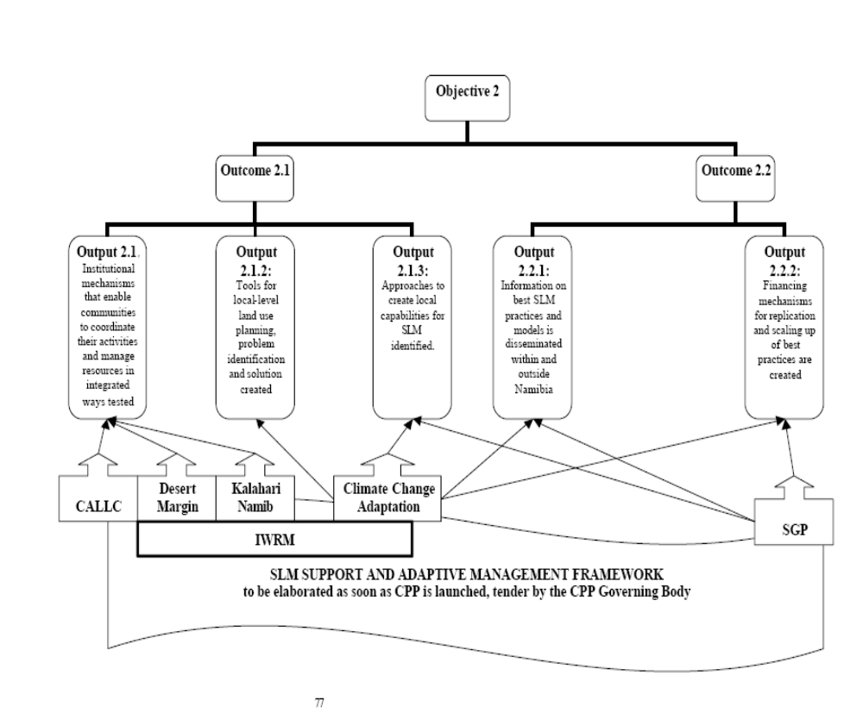

Sustainability and replicability

- The first phase of the CPP, which covers the expected lifespan of CALLC, will use GEF funding to build an enabling environment that will increase the capacity of the country to absorb and effectively employ investment funds for SLM activities at regional and local scales. By strengthening the institutional environment for SLM, and testing ways and means for organizing communities to spearhead community-based SLM activities, CALLC will help to demonstrate that strengthened institutional capacity at local level is necessary for sustainable land management. CALLC will also seek to identify opportunities for local economic development compatible with SLM objectives, helping to make the economic and financial case for investment by the private sector, and development banks at local level. This is expected to improve the opportunities for investments in land use diversification, as needed to reduce the impetus for current land uses that are placing pressure on the functional integrity of dryland environments.

- Institutional sustainability will be achieved through capacity building at all levels, following the principle of making impacts last, not projects. The capacity-building component aims to empower stakeholders at all levels, from national line Ministries to conservancy members and owners of small enterprises, to run their businesses smoothly beyond the end of the actual programme. A further, crucial, element is the strategy of building on, and adding value to, existing projects and practices, which have proven to work and to be sustainable.

- Sustainability at local-level is ensured through the partial devolution to local resource users of authority over land and resources management and the right to the benefits derived from using these resources. In addition to this, the development of the land use planning guidelines from Promoting Environmental Sustainability through Improved Land Use Planning (PESILUP) project through the World Bank (WB), and the contribution of local level monitoring information to the sustainable development index, will ensure that local resource users are empowered to take long-term management decisions based on relevant information. These actions, coupled with the creation of an enabling environment that provides the right incentives to resource users, should ensure conditions for sustaining SLM outcomes

- CALLC has been designed to engender the replication of good practices. New monitoring systems and decision support tools will be developed to ensure that decision making is responsive to the local management processes, allowing them to be adapted. Lessons and good practices will be distilled and progressively mainstreamed in sector investment activities. GEF support in capacity building and demonstration activities is targeted at catalyzing a paradigm shift from fragmented sectoral approaches to addressing land degradation to more integrated and sustainable land management approaches.

- The CPP and the CALLC project divert from subsistence living and take a “business” approach to SLM. In other words, through the identification of profitable SLM products, and the successful creation of a suitable investment environment, private sector but also communal investment into sustainable enterprise ventures will act as a catalyst to scale up SLM.

- The FIRM approach institutionalizes community leadership and creates a mechanism which ensures that resource users who understand local problems and the context choose what practices to adopt. Local ownership and management of knowledge, and a strong focus on information dissemination with the help of the CPP media strategy, will ensure that best practices are shared among stakeholders. This mechanism will be enhanced through linkages with the CBNRM support community and private sector.

Part III - Management Arrangements

- The project will be implemented over a period of three years, commencing early 2007 and ending in 2010. The UNDP will be the Implementing Agency (IA) for this Project. As the Implementing Agency, under GEF rules, it is charged with overall fiduciary and technical responsibility for the Project. In accordance with the Country Programme Action Plan (CPAP), signed by the Government of Namibia and UNDP, the National Planning Commission Secretariat (NPCS), as the Government Coordinating Authority, will be responsible for defining, assessing and monitoring project achievements towards country-level outcomes, hence responsible for project delivery and accountability.

- The project execution will follow a national execution (NEX) modality. The activities will be implemented by MAWF in partnership with an appropriate partner implementing NGO. It is envisaged that MAWF will outsource implementation of project activities to qualified and experienced individual(s) or organization(s) through a transparent process following UNDP/GEF and national tendering processes, in accordance with agreed TOR. MAWF will have ultimate accountability and financial responsibility over the project as per their bilateral agreement with UNDP. The Deputy Director of the Directorate of Extension and Engineering Services of the MAWF will assume the role of the National Project Director for the project. The overall accountability for the project lies with the National Planning Commission as the Government Coordinating Authority.

Project Implementation Arrangements

- This project will be executed by the MAWF through its Windhoek office and supporting offices in the four regions in accordance with standard NEX operational, financial guidelines and procedures. A Project Management Unit (PMU) will be responsible for day to day implementation of all the project activities. The PMU will consist of a Project Coordinator/Manager who will coordinate project activities and oversee progress in the demonstration areas; a highly knowledgeable Senior Technical Advisor will provide senior advice and general supervision; four field coordinators at local level will assist communities to participate in project activities and a Project Office Assistant will assist with day to day running of the office. The PMU will report to MAWF as the Executing Agency that will remain accountable to UNDP (the Implementing Agency) and to NPC (Government Coordinating Authority) for the delivery of agreed outputs as per the agreed project work plan schedule, and for financial management, including ensuring cost-effectiveness of project activities.

- A Project Steering Committee (PSC) will be established, in line with the demonstration and pilot activities under the CPP-ISLM in the north-central regions of the country. The PSC will consist of representatives of MAWF (Directorate of Extension and Engineering Services), other government ministries and departments, DRFN, and other demonstration projects (i.e. Climate Change Adaptation, PESILUP) in the regions. The PSC will be responsible for overseeing project activities at local level, and ensuring that agreed outcomes are delivered on schedule. It will also link the project to National level CPP management structures. Figure 3 represents the local level project management arrangements while figure 4 shows the linkage between the local level arrangement and the CPP overall management arrangements. At the national level, the project coordinator will channel information through the established MAWF national level committee for projects at least quarterly.

- All affected stakeholders will be involved in Project activities. During Preparation a full stakeholder analysis and involvement plan was developed and will be fully implemented and followed throughout the project duration (see section on “Stakeholders Involvement” in CPP framework MSP document).

- In order to accord proper acknowledgement to GEF for providing funding, GEF logo will appear on all CALLC project publications, including among others, project hardware and vehicles purchased with GEF funds. Any citation on publications regarding project will also accord proper acknowledgment to GEF. The UNDP logo should be more prominent and separated from the GEF logo if possible, as UN visibility is important for security purposes.
Figure 3: CALCC implementation arrangement

NPC
MAWF national level
Project Steering Committee
Project Management Unit
MAWF regional level
UNDP CO
CPP Coordination Unit

Part IV - Monitoring and Evaluation Plan and Budget

- The CPP will have M&E framework that will cover all its subprojects (including CALLC). In effect, the overall CPP M&E will build on the individual M&E systems and plans of the subprojects. Therefore CALLC will also have its independent evaluation as presented in this part.

- Project monitoring and evaluation will be conducted in accordance with established UNDP and GEF procedures. Section II provides: (i) the Logical Framework matrix and (ii) the M&E Plan matrix. The Logical Framework presents impact indicators for project implementation along with their corresponding means of verification. The M&E plan provides a detailed explanation of the monitoring and reporting system for the project and a presentation of the evaluation system. The work plan and the budget for M&E is given in Table 2.

- The Project Management Unit will be responsible for day to day monitoring activities. The Project Coordinator will be responsible for the preparation of reports for the Project Steering Committee and UNDP on a regular basis, including the following: (i) Inception Report; (ii) Annual Project Report; (iii) Project Implementation Review; (iv) Quarterly Progress Reports; and (v) Project Terminal Report. The Quarterly progress reports will provide a basis for managing project disbursements. These reports will include a brief summary of the status of activities, explaining variances from the work plan, and presenting work-plans for each successive quarter for review and endorsement. The Annual Project Report will be undertaken annually, and will entail a more detailed assessment of progress in implementation, using the set indicators. It will further evaluate the causes of successes and failures, and present a clear action plan for addressing problem areas for immediate implementation.

Figure 4: CPP Implementation Arrangements

CPP Governing Body

GoN
UNDP

Programme Level – CPP Framework

CPP Management Committee

CPP Consortium – Technical Advisory Body

CPP Coordination Unit

Project Mgt Unit
Project Mgt Unit
Regional Steering Committee
Project Mgt Unit
Project Mgt Unit
Regional Steering Committee

Project Level

Reporting
Advisory

Consultation
Inter-project Collaboration

- Annual Monitoring will occur through the Tripartite Review (TPR). This will serve as the highest policy-level meeting of the parties directly involved in the implementation of the project. The project will be subject to Tripartite Review (TPR) at least once every year. The first such meeting will be held within the first twelve months of implementation. The project proponent will prepare an Annual Project Report (APR) and submit it to UNDP-Namibia and the UNDP-GEF regional office at least two weeks prior to the TPR for review and comments.

- The project will be subjected to at least two independent external evaluations:
- Mid-term Evaluation – if feasible will be undertaken at the end of the second quarter of second year of implementation. The Mid-Term Evaluation will determine progress being made towards the achievement of outcomes and will identify course correction if needed;
- Final Evaluation - will take place three months prior to the terminal tripartite review meeting, and will focus on the same issues as the mid-term evaluation. The final evaluation will also look at impact and sustainability of results, including the contribution to capacity development and the achievement of global environmental goals.

Table 2: Indicative M&E work plan and budget for the Phases I and II

Type of M&E activity | Responsible Parties | Budget US$ | Time frame
Strategic Planning Matrix (annual work plan) | - PMU  - MAWF  - UNDP CO | 4,000 | Annually, first SPM immediately following approval of Phase II
Baseline and End-of Project Study of Project Indicators | - STA and PMU  - Hired consultant | 25,000 | Start and end of project.
Measurement of Means of Verification for Project Progress and Performance (measured annually) | - Oversight by UNDP-GEF RCU and STA  - Counterpart organizations in the field or hired consultants on an as-needed basis | Part of the SPM’s preparation. | Annually prior to APR/PIR and to the definition of annual work plans
APR-PIR | - Field Coordinators, NPM, STA and PMU  - UNDP-CO  - UNDP-GEF RCU | 0 | Annually
Steering Committee Meetings | - NPM, Field Coordinators and STA  - MAWF  - UNDP CO (if feasible) | 0 | Following Project IW and held quarterly
Technical reports | - STA,  - Field Coordinators | As part of project activities | To be determined by Project Team and UNDP-CO
Final External Evaluation | - PMU, MAWF  - UNDP-CO  - UNDP-GEF RCU  - External Consultants (i.e. evaluation team) | 13,000 | At the end of project implementation
Terminal Report | - PM, STA, PMU  - UNDP-CO  - MAWF | 0 | At least one month before the project’s end
Lessons learned | - STA, PM  - UNDP-GEF RCU (suggested formats for documenting best practices, etc) | 8,000 | Yearly
Audit | - UNDP-CO  - PMU | 4,000 | Yearly
Visits to field sites (UNDP and RCU staff travel costs to be charged separately) | - UNDP CO  - UNDP-GEF RCU (as appropriate)  - MAWF  - Government representatives | 20,000 | Yearly
TOTAL indicative COST  Excluding project team staff time and UNDP staff and travel expenses. |  | US$74,000

Part V - Legal Context

- This Project Document shall be the instrument referred to as such in Article I of the Standard Basic Assistance Agreement between the Government of Namibia and the United Nations Development Programme, as signed by the parties. The host country implementing agency shall, for the purpose of the Standard Basic Assistance Agreement, refer to the government co-operating agency described in that Agreement.

- The UNDP Resident Representative in Namibia is authorized to effect in writing the following types of revision to this Project Document, provided that he has verified the agreement thereto by the UNDP-GEF Unit and is assured that the other signatories to the Project Document have no objection to the proposed changes:

- Revision of, or addition to, any of the annexes to the Project Document;
- Revisions which do not involve significant changes in the immediate objectives, outputs or activities of the project, but are caused by the rearrangement of the inputs already agreed to or by cost increases due to inflation;
- Mandatory annual revisions which re-phase the delivery of agreed project inputs or increased expert or other costs due to inflation or take into account agency expenditure flexibility; and
- Inclusion of additional annexes and attachments only as set out here in this Project Document

Audit clause

- The Government Executing Agency, MAWF will provide the Resident Representative with certified periodic financial statements, and with an annual audit of the financial statements relating to the status of UNDP (including GEF) funds according to the established procedures set out in the UNDP RMG and Finance manuals. The Audit will be conducted by the legally recognised auditor of the Government, or by a commercial auditor engaged by the Auditor General.

Section II: Strategic and Resources Framework

Table 3: Logical Framework Analysis (including monitoring mechanisms for impact indicators)

Objectives | Key Performance Indicator  Target  End of Project |  | Target | Baselines and Benchmarks |  | Sampling Frequency
Project goal:  Improve natural resource based livelihoods, ecosystem stability, functions and services in the 4 North-Central regions (i.e. Ohangwena, Omusati, Oshana and Oshikoto) | CPP Area | Proportion of households in: | Target (2016) | Baseline (1993/94) | Benchmark (2011) | Parallel to Household Income and  Expenditure Survey conducted by  NPC every five years
 | North central | Absolute poverty | 2.5 | 8.35 | 5.0
 |  | Relative poverty | 20 | 32 | 25.0
Additional Information
Necessary to keep in mind that at goal level, CALLC alone will not achieve the set targets, but will “only” contribute to CPP goals. A household is defined as living in relative poverty if it devotes more than 60% of total income to food expenses, and in absolute poverty when more than 80% of total income is devoted to food expenses. Data are based on the Household Income and Expenditure Survey which is conducted on regular basis by NPC

 | Sustainable Development Index  (2016 – should we have 2009 instead, assumption is that this will be ongoing beyond project phase)  No participating FIRM shows  downward trends in SDI for  consecutive five years and participating FIRMs show  improve trends for at least two  consecutive years |  | 2006 n/a  (Baseline to be compiled in Year 1 of CALLC once SDI has been developed and  is applied) | 2007: collection of baseline  2009: no participating CBOs shows  downward trend for more than one year |  | Once baseline collected, twice: at  mid-term (end of 2nd quarter of year 2), and end  of project
Specific objective:  To create an enabling environment (knowledge, skills, capacity, and policies) for the adoption of sustainable land management practices in the Ohangwena, Omusati, Oshana and Oshikoto Regions. | Land condition indicators  20 Participating FIRMs show  improvements/no deterioration in LLM indicators |  | 2007: Collection of baseline | 2nd quarter of 2008: At least 12 participating FIRMs show improving trends in LLM indicators  End 2009: 20 Participating FIRMs show improving trends in LLM indicators |  | Twice during project  implementation: at mid-term and at end of project
Additional information:
LLM indicators include livestock conditions, vegetation / bush density, wildlife numbers, and incomes derived from natural resource activities. These are collected and evaluated by resource users on-the ground.

Outcome 1:  Local level institutional arrangement for effective partnerships in sustainable land management tested | 20 FIRMs established and operational in North-Central regions |  | 2006: 9 FIRMs are established in Oshikoto region by the Oshikoto Livestock Development Project | 2nd quarter of 2008: At least 12 FIRMs established  End 2009: 20 FIRMs established |  | Annually and at end of each year
Outcome 2:  Knowledge generated and used to support local level SLM and sustainable alternative livelihoods diversification strategies | Stocking practices are monitored and adjusted where necessary in 20 villages  At least 8 centers in the 4 North-Central regions have facilities for livestock auctions |  | 2007: Collection of baseline. LLM is practiced in communities in Oshikoto region  2007: Collection of baseline. Livestock auctions, supported by quarantining and other veterinary requirements, have been held in Otjikoto Region, but not in other North-Central regions. | End-2009: All DEES officers in North-Central regions familiar with LLM  2nd quarter of 2008: 12 new communities implementing LLM  End 2009: System for storing LLM information set up in MAWF to feed in to national environmental monitoring system  2nd quarter of 2008: 3 additional businesses set up in each region as a result of FIRM support  End 2009: 5 additional businesses set up in each region as a result of FIRM support |  | Annually, at end of each year

Table 4: Objectively Verifiable Impact Indicators at outcome and output levels

Goals, Specific objectives, Project outputs and Activities | Key performance indicators | Means of verification | Critical assumptions / Risks
Project goal:  Improve natural resource based livelihoods, ecosystem stability, functions and services in the Ohangwena, Omusati, Oshana and Oshikoto Regions | Increase in household incomes and other well-being indices (to be adopted from the UNDP M&E process)  Improvement in rangeland conditions (change in indices such as range condition, cover, species composition, etc.) | Household income and expenditure survey done by NPC  Local level monitoring indicators (LLM) | Continuous commitment from government and other support agencies  Gains made from the project are not undermined by climate change, inflation and other natural and man-made disasters
Specific objective:  To create an enabling environment (knowledge, skills, capacity, and policies) for the adoption of sustainable land management practices in the Ohangwena, Omusati, Oshana and Oshikoto Regions. | Acreage of land managed under the FIRMS  SLM mainstreamed in national and regional development processes  Number of households taking part in FIRMs and practicing SLM  Extent of diversification of local level economies | M&E reports by respective organisations  FIRMS CBNRM reports | Continued interest and involvement of MAWF officials as well as NGO and private sector parties  DEES, DWA and communities maintain their interest and involvement in FIRMs, LLM and IWRM.
Outcome 1:  Local level institutional arrangement for effective partnerships in sustainable land management tested | Number of households and CBOs participating in FIRMs | CBNRM reports
Outcome 2:  Knowledge generated and used to support local level SLM and sustainable alternative livelihoods diversification strategies | Capacity of FIRMs to influence decision making processes at local levels | CBNRM and FIRM reports
Project Outputs:  Output 1.1: An awareness strategy on the importance and benefits of FIRMs is developed and implemented | Number of households and organizations participating in awareness activities | DEES annual reports  Awareness materials available
Output 1.2: FIRMs established and operational | 20 community level multi-sectoral forums (FIRMS) in operation | DEES annual reports will show the number of FIRMs and involvement of DEES staff in them. | Interest and involvement of all parties in FIRMs (Govt, NGO and private sector) is maintained.
Output 1.3: Capacity of various stakeholders to participate effectively in the FIRMs strengthened | All established FIRMs have LLM systems and use these systems  Stocking practices are adjusted in 20 villages following recommendations from the local level monitoring systems established in the project. | DEES annual reports will show where and how many LLM systems are operational.  LLM database, maintained by communities and by DEES, will indicate if stocking rates are being adjusted appropriately. | Commitment by DEES to implement LLM is maintained.  Interest and involvement of all parties in FIRMs (Govt, NGO and private sector) is maintained so that local communities can use a variety of ways to increase and reduce livestock numbers in pace with rangeland conditions.
Output 1.4: Policy recommendations for local level policy reform in support of SLM and FIRMs formulated | Review polices enacted | Reviewed policies | Government remains committed to policy change
Output 2.1: Opportunities for profitable diversification of livelihoods are identified. | Description of marketing options and alternative income generating options | FIRM reports | Willingness of private sector to participate in project and to facilitate increased marketing
Output 2.2: Communities, Government extension officers and private sector entrepreneurs are capacitated to implement appropriate marketing and business activities and to monitor, evaluate and adjust the processes and impacts of these activities. | Increase in commercial activities  Increase in household incomes | Reports on business activities | Communities interested in identified business and marketing opportunities
Output 2.3: Improved land management practices identified and promoted | Number of households which implement identified SLM methods  Improvement in rangeland conditions | DEES reports  LLM indicators | Communities willing to change land management practices
Output 2.4: An M&E system developed and information collected and used to support adaptive management | Number of households practicing adaptive land management | Project reports  LLM indicators | Communities are willing to participate in the process

Table 5: Results and Resources Framework

Outcome 1: Local level institutional arrangement for effective partnerships in sustainable land management tested
Applicable CPAP and MYFF Outcomes: CPAP Outcome 4.9 Strengthened Sustainable Land and Water Management & MYFF Outcome 11: Framework for Country Pilot Partnership for Sustainable Land Management Developed and Adopted
Intended outputs | Output indicators | Indicative activities | Input/Resources (USD)
Output 1.1: An awareness strategy on the importance and benefits of FIRMs developed and implemented | 1.1.1 Number of households and organisations participating in awareness activities | 1.1.1 Hold meetings with relevant stakeholders to introduce the FIRM concept and ensure participation of these stakeholders  1.1.2 Identify best media for awareness raising  1.1.3 Produce and distribute publications  1.1.4 Participate in relevant conferences and workshops | 665, 000
Output 1.2:  Forums for Integrated Resource Management are established and functional | - Number of regional planning workshops  - Number of FIRMs established  - Number of organisations and individuals participating in FIRMs  - Acreage of land managed under FIRMS | 1.2.1 Facilitate the establishment of FIRMs through community visits  1.2.2 Facilitate the development of integrated workplans  1.2.3 Facilitate the development and implementation of local level monitoring  1.2.4 Facilitate a process of informed decision making (using LLM) | 665, 000
Output 1.3:  Capacity of various stakeholders to participate effectively in the FIRMs strengthened | - Number of established FIRMs with Local level monitoring systems developed  Number of households and organisations using LLM as basis for decision making | 1.3.1 Identify training needs  1.3.2 Identify and prepare training material  1.3.3 Facilitate/conduct training  1.3.4 Facilitate development and implementation of integrated workplans | 665, 000
Output 1.4:  Policy recommendations for local level policy reform in support of SLM and FIRMS formulated | 1.4.1 Number of policies and regulation enacted as a result of the project | 1.4.1 Review relevant policy documents  1.4.2 Invite and arrange policy makers to FIRM sites  1.4.3 Participate in relevant developmental processes  1.4.4 Promote Firm and relevant gatherings | 665, 000
Output 2.1:  Opportunities for profitable, viable and sustainable strategies for diversification of livelihoods identified | 2.1.1 List of alternative income generating activities  2.1.2 List of options for appropriate marketing in north-central | 2.1.1 Identify opportunities for diversification of livelihoods  2.1.2 Liaise with commercial farmers and other private organisations  2.1.3 Undertake exchange visits | 335, 000
Output 2.2  Communities, Government extension officers and private sector entrepreneurs are capacitated to implement appropriate marketing and business activities and to monitor, evaluate and adjust the processes and impacts of these activities | 2.2.1 Numbers of households, government extension officers, private sector entrepreneurs making use of activities identified in 2.1  2.2.2 Percentage of households augmenting a percentage of their household incomes from sustainable alternative livelihood options | 2.2.1Build capacity in community members, government extension officers, locally-operating NGOs and private sector enterprises to implement business activities  2.2.2 Monitor, evaluate and adjust entrepreneurial activities to keep them environmentally and economically sustainable | 335, 000
Output 2.3: Improved land management practices identified and promoted | 2.3.1 Number of people involved in commercial activities as a result of project  2.3.2 Increase in household incomes | 2.3.1 In consultation with local communities and service organisation identify SLM practices  2.3.2 Pilot the identified practices  2.3.3 Document lessons learned and promote best practises | 335, 000
Output 2.4: An M&E system developed and information collected and used to support adaptive management | 2.4.1 Number of households practising adaptive land management | 2.4.1 Organise and participate in M&E to assess and guide progress  2.4.2 Incorporate M&E results into training and other FIRM activities  2.4.3 Document and disseminate information | 335, 000
Total 1,000,000

Table 6: Assumptions and Risks

Risk | Risk rating | Risk mitigation measure
Changes in national commitment towards environmentally sustainable development | Low | - CPP and CALLC build on national development priorities thereby create linkages with National Development Plans and Vision 2030  - CPP to firmly anchor SLM into development priorities through mainstreaming into NPRAP and forthcoming NDPs to ensure future commitment.
Changes in MAWF commitment and interest towards the project | Medium | - CALLC to that activities are directly contributing to support ministries objectives
Changes in local communities commitment and interest towards FIRMs | Medium | - CPP will ensure that traditional authorities and community members are involved in project planning and implementation from the beginning.
Reduction in human capacity due to HIV/AIDS | High | - HIV/AIDS to be mainstreamed into institution building  - Particular attention to the effects of HIV/AIDS will be paid when testing local-level management practices and for training and capacity building activities  - CPP and CALLC to ensure close linkages between the project and HIV/AIDS interventions

SECTION III: TOTAL BUDGET AND WORKPLAN

Table 7: CALLC Atlas budget

 | Award ID: TBD
 | Award Title: PIMS MSP LD: CALLC 3886?
 | Project ID: TBD
 | Project title: Enhancing Institutional and Human Resource Capacity through Local Level Coordination of Integrated Rangeland Management and Support (CALLC)
Project Outcomes /Atlas Activity |  | Responsible Party | Source of Funds | PLANNED BUDGET & WORKPLAN
 |  | Responsible Party | Source of Funds | Atlas Budget Code | Atlas Budget Description | 2007 | 2008 | 2009 | 2010 | Total Amount (USD)
Outcome 1:  Local level institutional arrangement for effective partnerships in sustainable land management tested |  | MAWF | GEF | 71400 | Contractual Services - Individual | 0 | 30,000 | 25,000 | 30,000 | 85,000
 |  | MAWF | GEF | 71200 | International Consultants | 0 | 10,000 | 10,000 | 10,000 | 30,000
 |  | MAWF | GEF | 71300 | Local Consultants | 0 | 50,000 | 45,000 | 35,000 | 130,000
 |  | MAWF | GEF | 71500 | UN GEF- Volunteer (ARMADA) | 0 | 40,000 | 55,000 | 10,000 | 105,000
 |  | MAWF | GEF | 71600 | Travel | 2,000 | 40,000 | 25,000 | 10,000 | 77,000
 |  | MAWF | GEF | 72200 | Equipment and Furniture | 3,000 | 30,000 | 5,000 | 0 | 38,000
 |  | MAWF | GEF | 72400 | Communication and Audio Visual Equipment | 5,000 | 10,000 | 10,000 | 0 | 25,000
 |  | MAWF | GEF | 72500 | Supplies | 0 | 5,000 | 5,000 | 5,000 | 15,000
 |  | MAWF | GEF | 72800 | Information Technology Equipment | 0 | 40,000 | 15,000 | 5,000 | 60,000
 |  | MAWF | GEF | 73400 | Rental and Maintenance of Equipment | 0 | 5,000 | 5,000 | 5,000 | 15,000
 |  | MAWF | GEF | 74100 | Professional Services | 0 | 5,000 | 5,000 | 5,000 | 15,000
 |  | MAWF | GEF | 74200 | Audio Visual and Printing Production Costs | 5,000 | 15,000 | 15,000 | 15,000 | 50,000
 |  | MAWF | GEF | 74500 | Miscellaneous Expenses | 2,000 | 6,000 | 6,000 | 6,000 | 20,000
 |  | MAWF | GEF | TOTAL OUTCOME 1 |  | 17,000 | 286,000 | 226,000 | 136,000 | 665,000
Outcome 2:  Knowledge generated and used to support local level SLM and sustainable alternative livelihoods diversification strategies |  | MAWF | GEF | 72100 | Contractual Services- Companies | 0 | 25,000 | 30,000 | 10,000 | 65,000
 |  | MAWF | GEF | 71600 | Travel | 0 | 20,000 | 20,000 | 20,000 | 60,000
 |  | MAWF | GEF | 71300 | Local Consultants | 0 | 24,000 | 35,000 | 25,000 | 84,000
 |  | MAWF | GEF | 71200 | International Consultants | 0 | 30,000 | 35,000 | 15,000 | 80,000
 |  | MAWF | GEF | 74200 | Audio Visual and Printing Production Costs | 0 | 11,000 | 10,000 | 10,000 | 31,000
 |  | MAWF | GEF | 74500 | Miscellaneous | 0 | 5,000 | 5,000 | 5,000 | 15,000
 |  | MAWF | GEF | TOTAL OUTCOME COST |  | 0 | 115,000 | 135,000 | 85,000 | 335,000
TOTAL |  |  |  |  |  | 17,000 | 401,000 | 361,000 | 221,000 | 1,000,000

Other Financial Modalities – CPP Overall Project Financial Modalities

- GEF contributions towards the first phase of CPP objectives are based on a three tier modality and comprise firstly, a national grant to the country through the CPP Programme (US$ 10,250 million comprised of US$ 9,000 million from OP15, US$ 1,000 million from SPA and US$ 250k in preparatory assistance for the CPP Programme Framework); secondly, a grant for regional activities which are embodied in the Desert Margin Project (US$ 771,080 for the second tranche) and the Kalahari-Namib project (US$ 800,000) and thirdly grants for local activities, through the GEF Small Grants Programme (US$ 237,277 has been earmarked for SLM projects) (figure 3). The GEF support for the CPP in phase 1 amounts to US$ 12,058,357. A total of US$ 51,988,613 in co-financing has been secured by the Government of Namibia. A breakdown is provided in Table 8.

Table 8: Co-financing Sources for CPP (5 years)

Co-financing Sources
Name of co-financer (source) | Classification | Amount (US$) | Status*
GTZ | Bilateral Agency | 250,941 | Confirmed
MAWF | Ministry | 13,140,872 | Confirmed
MLR | Ministry | 18,197,133 | Confirmed
MRLGHRD | Ministry | 1,206,636 | Confirmed
MET | Ministry | 2,262,443 | Confirmed
NPC | Ministry | 1,659,125 | Confirmed
EU | Multilateral | 15,056,463 | Confirmed
UNESCO | Multilateral Donor | 15,000.00 | Confirmed
UNDP | Multilateral Donor / IA | 200,000 | Confirmed
TOTAL |  | 51.988.613

- The table below provides the CPP finance per outcome. CALLC contributes mainly to outcome 2.1, but also forms close linkages to the other outcomes. Co-financing for CALLC is apportioned from MAWF co-finance contributions to outcome 2.1.

Table 9: CPP Finance by Outcome/ Output
CPP Programme Components | GEF  US$ | Regional Projects | SGP | Co-Finance  US$ | TOTAL  US$
 | Country Programme
Outcome 1.1Policies related to land management and production are harmonised and incentives for SLM created and/or strengthened. | 500,000 |  |  | 6,713,912 (EU +MET +UNDP) | 7,213,912
Outcome 1.2Enabling institutional mechanisms and linkages that support coordinated community-led SLM endeavours are promoted. | 1,000,000 |  |  | 7.138.129 (MAWF, UNDP) | 8.138.129
Outcome 1.3Individual capacity to implement SLM is strengthened at all levels. | 1,500,000 |  |  | 11.214.616 (EU, MAWF) | 12.714.616
Outcome 1.4Effective Monitoring and Evaluation systems in place for adaptive management at local and national levels. | 1,500,000 |  |  | 11.149.884 (MLR, NPC, GTZ) | 12.649.884
Outcome 2.1Management methods, models and best practices for SLM identified and tested | 4,000,000 | 1.571.080 | 100,000 | 3.122.389 (MAWF, MRLGHRD, UNESCO) | 8.793.469
Outcome 2.2 Best practices are shared and replicability tested | 1,500,000 |  | 137,277 | 12.569.683 (MAWF, MLR) | 14.206.960
TOTALS (US$) | 10,000,000 | 1.571.080 | 237,277 | 51.908.613 | 63.716.970
Preparatory Assistance | 250,000 |  |  | 80,000 (UNDP)

Incremental Cost Analysis

- The following section presents the baseline contributions and incremental costs that GEF funding will cover for the CPP and CALLC in particular. Annex A to the CPP Programme Framework (Executive Summary) spells out the Incremental Cost Analysis in considerable detail.

National Development Objectives

- Namibia has framed a 30-year Development Vision and constructed a National Development Plan (NDP II) to guide and ensure the coherence of development strategies across different sectors. Key development objectives stipulated in NDP II include ensuring sustainable economic development and food security, assuring good governance and controlling HIV/AIDS. The principle of sustainable development is underscored as an imperative in development strategies. This reflects the heavy dependency of the Namibian economy on natural resources. While the government has recognized the importance and is fully committed to combat land degradation insufficient capacity at systemic, institutional and individual level and insufficient information on land degradation create barriers to tackle the problem adequately.

- In accordance with Vision 2030, CALLC will create opportunities for income generation and employment and diversify livelihoods through the identification of sustainable income generating activities; it will engender close collaboration between institutions and the creation of partnerships which are considered crucial for sustainable economic development; it will promote equity and equal access to natural resources through its focus on decentralization and the transfer of management rights to local resource users; and it will target the preservation of Namibia’s resource base through integrated cross-sectoral planning of resource management. Finally, CALLC will address both of the processes which are necessary to empower people to take action: it will strengthen the enabling environment by pursuing the objective of empowering local communities and authorities to lead decision making through institutional decentralization and, at the same time, will contribute to efforts to build the human and institutional capacity of all stakeholders at local-level and, particularly, will enable the partner Ministries to satisfy the obligations arising from decentralization requirements.

Global Environmental Objectives

- Land degradation impairs the integrity of ecosystems, undermining their functioning within the global system. It threatens Namibia’s drylands, a rich and globally significant storehouse of biodiversity with high species richness, biological distinctiveness and habitat diversity; it reduces Namibia’s capacity to act as carbon sink and further jeopardizes globally significant wetlands.

- Land degradation is also an increasing problem in most parts of Namibia. There are two main types of land degradation in North-Central Namibia, the selected pilot region for the project, including (i) vegetation degradation which includes rangeland degradation, deforestation and degradation of woodlands, (ii) soil degradation which includes soil erosion and loss of soil fertility.

System Boundary

- The systems boundary for the baseline cost analysis for the CPP framework has been set to include all spending of the key Ministries (MET, MAWF, MLRGHRD, MLR, NPC) out of their operational and development budgets that contribute to the achievement of any of the programme outcomes. Further, non-governmental and donor expenditures have been incorporated in so far as they contribute to national programmes. Although the programme will run over a total of 10 years, the Incremental Cost Analysis focuses solely on Phase 1, which covers a period of five years. It is necessary to keep in mind that Government expenditure (which makes up most of the baseline contributions accounted for) is confirmed only for the respective current financial year. In Namibia, the 3-year Medium Term Expenditure Framework provides estimations of spending up to the financial year 2007/2008. Consequently, the cost figures for the remaining three years that the CPP extends beyond the time frame of the current MTEF are estimations, based on forward projections.

- Baseline Scenario can be summarised as helper against the outcomes of the CPP:

Table 10: Baseline scenario for CPP

Outcomes | Baseline Amount (US$)
1.1 Systemic capacity | 12,563,650
1.2 Institutional capacity | 125,485,377
1.3 Individual capacity | Nil
1.4 Knowledge | 5,494,423
2.1 Local level Support | 175,657,824
2.2 Replication | 4,223,228
Total Baseline | 323,424,228

- The Increment can be calculated as 63,716,470 US$, of which GEF contributes 10,000,000 via this CPP, plus 1,808,357 US$ via other GEF inputs (UNEP/SGP). The GEF intervention is thus 15% of the overall increment (a co-finance rate of 1:5) and 3% of overall alternative (baseline plus increment). The GEF investment is channelled through the four GEF projects (figure 1 and table 1). The first three are described in three project documents which are stand alone but are linked by the coordination, monitoring and evaluation processes provided in CPP-SAM.

SECTION IV: ADDITIONAL INFORMATION

Part I: Approved MSP

- The approved CPP is attached as annex 1

Letters of Endorsement

- Letters of endorsement are attached.

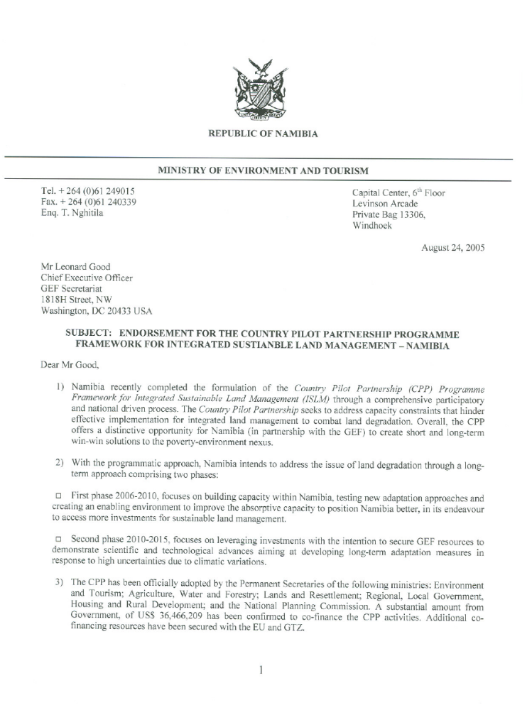
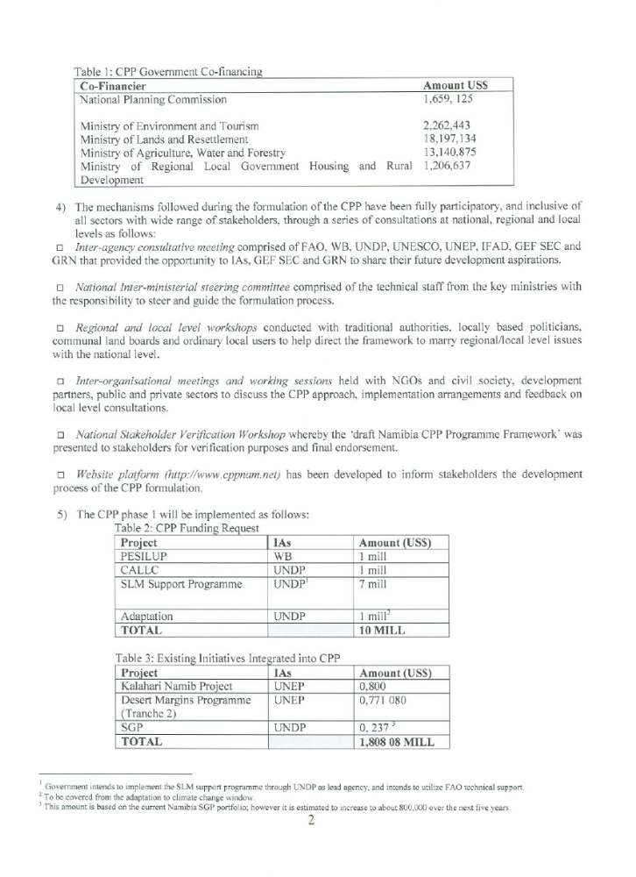

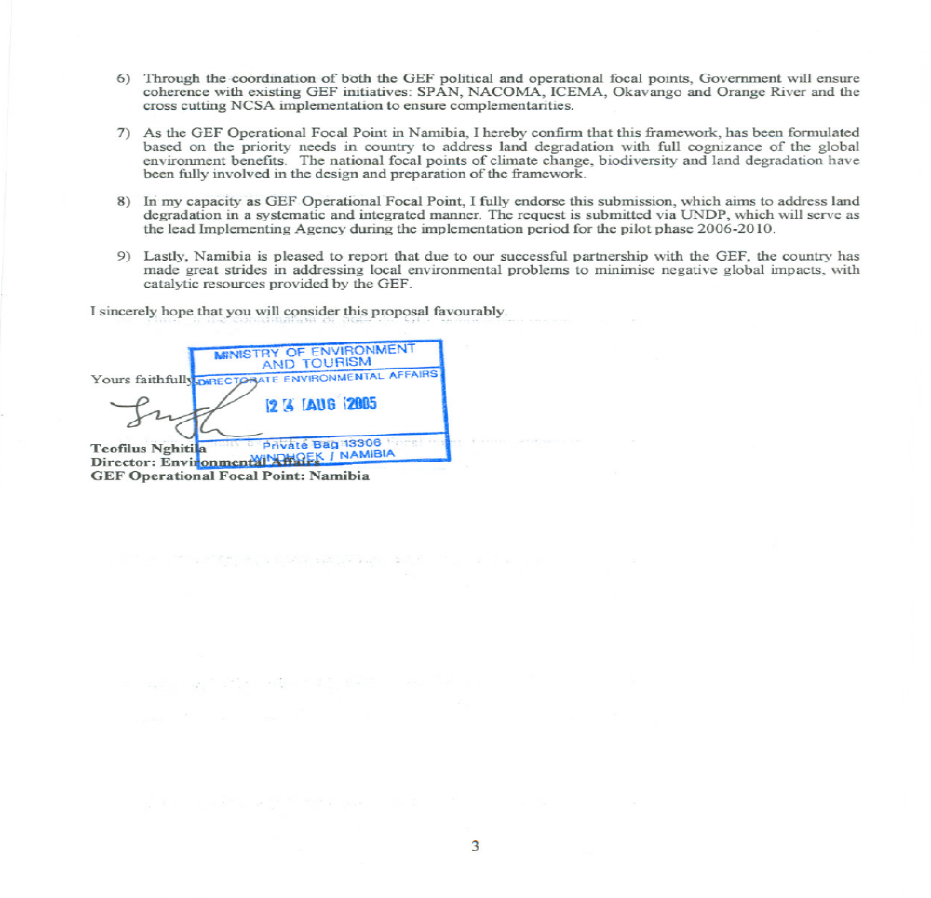

Part III: Terms of Reference for key Project Staff and main sub-contracts

Project Management Unit for the project:
- Institutional and human Resources Capacity through Local level Coordination of Integrated Rangeland management and Support (CALLC)) in Namibia under the Country Pilot Partnership for integrated sustainable land management (CPP-ISLM). 3 year contract renewable subject to satisfactory performance

- A Project Management Unit (PMU) will be established under the CALCC project. The unit will consist of a Project Coordinator, a technical advisor, Project Office Assistant and 4 Field coordinators (TORs for the following positions are outlined below). The PMU will be responsible for day to day implementation of the project activities and ensure that the project meets its objectives. The PMU will link the project to the wider CPP, ensuring that it is informed by the lessons generated from the other CPP projects. They will be responsible for monitoring and will provide secretariat services to the Project Steering Committee.

- Implementation of project components - Services of individual(s) or organization(s) to implement the following two components of CALCC required.

- Component 1: Local level institutional arrangement for effective partnerships in sustainable land management tested. Key requirements are as follows:

- Namibia based organization (should be registered), offices in north-central Namibia will be an added advantage
- Working experience and relevant qualifications in natural resources management (preferably in Namibia)
- Good understanding of environment and development issues in Namibia
- Work experience in rural Namibia (preferably in north-central regions)
- Experience in institution building, preferably land management institutions
- Knowledge of north-central Namibia environment
- Local level and rural development planning and results-oriented management with strong financial management;
- Strong team building, interpersonal skills and willingness to work towards local capacity building;
- Experience in donor-supported and international cooperation project;
- Demonstrable skills in Information Technology, including use of Word Processing, Power Point, spread sheets, email and internet;
- Proven record of good financial management and transparency

- Component 2: Knowledge generated and used to support local level SLM and sustainable - Key requirements are:

- Namibia based organization (should be registered), offices in north-central Namibia will be an added advantage
- Working experience and relevant qualifications in natural resources management and resource economics (preferably in Namibia)
- Experience in community outreach activities
- Work experience in rural Namibia (preferably in north-central regions)
- Experience in institution building, preferably land management institutions
- Knowledge of north-central Namibia socio-economic environment
- Local level and rural development planning and results-oriented management with strong financial management;
- Strong team building, interpersonal skills and willingness to work towards local capacity building;
- Experience in donor-supported and international cooperation project;
- Demonstrable skills in Information Technology, including use of Word Processing, Power Point, spread sheets, email and internet;
- Proven record of good financial management and transparency

Project Coordinator (PC)

- Duty Station: TBD: 2 year contract renewable subject to satisfactory performance.

- The Project Coordinator (PC) shall be the head of the project management unit (PMU) and shall be responsible for the overall coordination of both technical and administrative aspects of the CALLC project management unit. He/she shall liaise directly with designated officials of the Executing Agency and the Ministry of Agriculture, Water and Forestry, UNDP Country Office, the GEF Operational Focal Point, the existing and potential additional project co- financiers and others as deemed appropriate and necessary by the PMU. The budget and associated work plan will provide guidance on the day-to-day implementation of the approved Project Document. He/she shall be responsible for delivery of all substantive, managerial and financial reports from and on behalf of the Project. He/she will provide overall supervision for all the PMU staff.

- Duties and Responsibilities of the project coordinator: - The Project Coordinator will have the following specific duties:

- Lead, manage and coordinate the day to day management of the PMU to be established in Windhoek including administration, accounting, technical expertise, and actual project implementation and reporting;
- Lead the development of detailed project implementation inputs including preparation of subcontractors terms of reference, identification and selection of national, regional and international subcontractors, cost estimation, time scheduling, contracting, and reporting;
- Coordinate activities of consultants including contract management, direction and supervision of field operations, logistical support, review of technical outputs/reports, measurement /assessment of project achievements before submitting to stakeholders;
- Supervise the field level coordinators at each FIRM and provide substantive support and coaching to their work;
- Plan and coordinate various workshops identified in this Project Document, including assistance in the design, supervision and where possible delivery of the training and outreach activities of the project;
- Provide technical assistance in rangeland and sustainable land management policy discussions and development;
- Assist in developing policy frameworks to showcase and demonstrate direct benefits from SLM to human-well being in Namibia;
- Mobilise additional resources for the project; and
- Liaise with all CPP partners and various steering committees as needs be.

- S/he will also have the following specific responsibilities:

- Organize the project steering committee meetings in coordination and support of other north central demonstration projects, i.e. CCA and IWRM;
- Prepare quarterly progress, technical and financial reports for submission to the steering committee and to UNDP;
- Manage quality control and timely delivery of project outputs;
- Monitor the project progress in accordance with the project monitoring and evaluation plan;
- Attend and participate in all CPP Umbrella activities specifically, CPP consortium and associated events; and
- Undertake other management duties that contribute to the effective functioning of the project.

- Key Qualifications of the project coordinator: The project coordinator will be a Senior Expert with considerable experience of at least 10 years in project management. He/she must have at least a Master’s degree in biological sciences, desert and arid ecology, rangeland, or any field related to sustainable land management. He/she will have extensive experience of not less than 7 years natural resources management and a good track record for having contacts with professionals, government institutions/agencies and the development partners based in Namibia. The PC will also possess strong applied local level monitoring systems and management experience. The PC must have experience of working with government departments and NGOs as well as CBOs in Namibia. In either case, candidates must also fulfill the following conditions:

- Work experience within the rural and community-based institutions;
- At least seven (7) years natural resources management experience and working knowledge of the Namibian environment sector with extensive contact in the public and private sectors and civil society organizations;
- At least five (5) years work experience at senior management level with demonstrable project level management skills and ability to coordinate activities involving a large contingent of professional consultants drawn around the country and/or internationally;
- Local level and rural development planning and results-oriented management with strong financial management;
- Strong team building, interpersonal skills and willingness to work towards local capacity building;
- Experience in donor-supported and international cooperation project;
- Demonstrable skills in Information Technology, including use of Word Processing, Power Point, spread sheets, email and internet;
- Fluent communication skills (oral & written) in English.

Senior Technical Advisor:
- Duty Station: TBD. 2 year contract renewable subject to satisfactory performance. The Senior Technical Advisor will provide senior guidance to the project and will direct the project to achieve its intended results. S/he will be directly involved in the practical implementation of CALCC activities at the Pilot sites and feed lessons learned into technical coordination, strategic planning, policy development and mainstreaming activities. Duties and Responsibilities of the Senior Technical Advisor will include but are not limited to the following tasks:

- Guide and participate in the development of an awareness strategy for the project
- Advice the identification of stakeholders to participate in FIRMs, liaise with stakeholders wherever appropriate
- Provide guidance in the establishment of FIRMs at local levels
- Guide and facilitate the development of local level monitoring systems in sustainable rangeland management
- Guide rural communities to translate LLM results into decision making tools and apply the results into daily planning
- Guide in the identification and development of capacity building programmes
- Participate in strategic planning at local and national levels
- Mainstream project results into national development processes and into policy development
- Drive market analyses to identify the economic viability of ISLM enterprises with participation of interested entrepreneurs.
- Facilitate the drafting and finalisation of business plans with communities and support organisations.
- Link resource entrepreneurs with existing funding opportunities (e.g. small grants).
- Establish partnerships and liaise with other relevant service providers and partners such as the private sector in the respective regions; the Ministry of Trade and Investment; the Ministry of Health; NACSO Business and Enterprise Group; CRIAA amongst others.
- Provide assistance to the M&E Specialist (at CPP framework level) to ensure that the project is adequately monitored, evaluated and reported within the CPP M&E Plan
- The Senior Technical Advisor shall work in close collaboration with the CPP Senior Technical Livelihood and Business/Enterprise Advisor

- Key Qualifications of the project Senior Technical Advisor are:
- At least 10years work experience in rural community development or similar positions, of which minimum 5 years at senior management level;
- Working knowledge of the Namibian environment sector with extensive contact in the public and private sectors and civil society organizations;
- Local level and rural development planning and results-oriented management with strong financial management;
- Good knowledge of socio-economic and environmental conditions of North-Central regions of Namibia
- Experience in donor-supported and international cooperation project;
- Fluent communication skills (oral & written) in English.

Field coordinators/facilitators (FCs) - 4

- Duty Station: Demonstration Sites: The North Central Regions (Oshikoto, Ohangwena, Omusati and Oshana). They will have 2-year contract renewable subject to satisfactory performance. The Field Coordinator (FC) at each demonstration site shall supervise and implement the field level activities at the site and shall be responsible for the overall coordination of both technical and administrative aspects of the project activities. He/she shall work closely with the FIRMS, Regional Councils and CBOs. The FF shall report directly to the Project Coordinator, based in the DRFN). The budget and associated work plan for field and demonstration interventions will provide guidance on the day-to-day implementation of the approved activities. The FF shall also be responsible for delivery of all substantive, managerial and financial reports from and on behalf of the Project at the site. He/she will provide overall supervision at the demonstration site especially supporting the establishment of FIRMs.

- Duties and Responsibilities of the field coordinator: The Field Facilitator will have the following specific duties and responsibilities:
- Lead, manage and coordinate the day to day management of the project activities at the demonstration site level ;
- Lead the development of detailed site-level implementation inputs including preparation of work plans;
- Coordinate outreach activities including local level monitoring, direction and supervision of field operations, logistical support, review of technical outputs/reports, measurement /assessment of project achievements before submitting to stakeholders;;
- Plan and organize meetings and workshops at site level (FIRMs), including assistance in the design, supervision and where possible delivery of the training and outreach activities within the demonstration area;
- Manage quality control and timely delivery of project outputs;
- Participate in the regional project steering committee meetings;

- Key Qualifications of the field coordinator: The field facilitator will be an Expert with experience of at least 3-5 years in project management. He/she must have at least an Advanced degree in biological sciences, arid and desert ecology or any field related to natural resource management. He/she will have experience of not less than 3 years with demonstrable community-based experience. In either case, candidates must also fulfill the following conditions:

- Experience with community-based natural resources management;
- At least three (3) years natural resources management experience and working knowledge of the Namibian environment sector with extensive contact in the public and private sectors and civil society organizations;
- At least five (3) years work experience at local level with local level, participatory and rural development skills and ability to coordinate outreach activities involving a wide range of stakeholders;
- Strong team building, interpersonal skills and willingness to work towards local capacity building;
- Demonstrable skills in Information Technology, including use of Word Processing, Power Point, spread sheets, email and internet;
- Fluent communication skills (oral & written) in English.

Project Office Assistant

- Duty Station: TBD. S/he will be on a 2 year contract renewable subject to satisfactory performance. Working as a part of the Project Management Unit (PMU), the Assistant is responsible for day-to-day administrative and logistical tasks of the project, including procurement, filing and other clerical and technical duties. The Assistant shall report directly to the Project Coordinator (PC). He/she will provide on the job training for interns and support the four field facilitators.

- Duties and Responsibilities will include:
- Ensure that all procurement is carried out in accordance with UNDP/GEF and Government of the Republic of Namibia (GRN) requirements within the mandate of DRFN as implementing organization;
- Becoming conversant with UNDP/GEF financial management and reporting procedures including use of UNDP ATLAS system and financial advance modality;
- Working with the DRFN Accountant Officer, to ensure smooth flow of funds, to enable timely execution of contracts including timely replenishment of the project accounts, arrange for annual audits of all accounts;
- Compile quarterly and annual financial reports for regional project steering committee and (FIRMs), focusing on financial delivery and rate of implementation of the overall project
- Maintain good filing system at the PMU including information and library materials within the DRFN;
- Manage the project resources e.g. office equipment/stationary, including management of project vehicles if appropriate, ensuring appropriate use and maintenance;
- Maintain updated system of all assets and inventory list (asset number, location) of all equipments purchased with project funds;
- Assist the field facilitators in all other administrative and clerical work.

- Key Qualifications: The candidate must fulfill the following conditions:
- A Bachelors (BA) Degree or Polytechnic Diploma or equivalent work experience;
- A track record in office management and procurement;
- Evidence of working with donor agencies, government and non-governmental organizations in Namibia;
- Ability to work without supervision in meeting set guidelines;
- Good understanding of project management;
- One technical experience in a discipline relevant to the CALLC project;
- Excellent IT skills and;
- Fluency in English
- Efficiency and maturity
- Ability to work in a team

Signature Page

Country: NAMIBIA

UNDAF Outcome: By 2010, livelihoods and food security among most vulnerable groups are improved.

Expected Outcome(s):
- Institutional mechanisms tested that enable communities working in partnership with key support agencies to develop their goals and manage activities for ISLM.
- Cost-effective approaches that build local capabilities to bridge skills gaps for ISLM and livelihood diversification identified and tested.

Expected Output(s):
- Forums for Integrated Resource Management (FIRMs) are established and functional.
- An effective local level decision support system (local level monitoring) is in place and functional, contributing to implementation of sustainable land use management practices.
- Opportunities for profitable diversification of livelihoods are identified, using FIRMs as the platform and information gathered through local level monitoring.
- Communities, Government extension officers and private sector entrepreneurs are capacitated to implement appropriate marketing and business activities and to monitor, evaluate and adjust the processes and impacts of these activities.

Implementing partners: MAWF (Cooperating Agency)
Other Partners: MET, MLR, MRLGHRD and NPC
Total budget (PDF-B): USD 1,000,000
Allocated resources:
- GEF: USD 1,000,000 (MSP)

- In kind contributions USD

Programme Period: 2006-2010
Programme Component: Energy and environment for sustainable development
Project Title: Enhancing Institutional and Human Resource Capacity through Local Level Coordination of Integrated Rangeland Management and Support (CALLC)
Project ID (GEF PIMS): PIMS 3138 LD MSP CALLC: Project ID (Atlas): TBD
Project Duration: 36 months
Management Arrangement: National Execution

Agreed by:
On behalf of: | Signature | Date | Name/Title
Government of Namibia |  |  | Mr Mocks Shivute  Permanent Secretary, National Planning Commission Secretariat
Government Cooperating Agency |  |  | Ms Kahijoro Kahuure  Permanent Secretary, Ministry of Agriculture, Water and Forestry
UNDP |  |  | Mr. Simon R. Nhongo  Resident Representative, UNDP Namibia

The CPP will be implemented in two phases at both national and local levels. During the first phase (2006-2010), GEF activities will be carefully applied to build Namibia’s capacity to absorb investments in combating land degradation. At national level, GEF resources will be dedicated towards building capacity at the systemic, institutional and individual scales to plan, execute and monitor SLM activities. At a local level resource users will be empowered to assess sustainable land use management options and draw down extension services and support from service providers according to their particular land management needs. Local level activities will identify investment opportunities for SLM that uncover win-win solutions for SLM by testing new adaptation approaches that reduce pressure on land resources and attach an economic value to the conservation and sustainable management of drylands. The second phase (2010 – 2015) will focus on leveraging investments to consolidate progress made in phase 1, scale up best practices which have been identified during the first phase and advance state of the art measures to adapt SLM approaches to anticipated long-term climatic changes. These interventions will ensure that land is not just conserved but also productively used, thus ensuring the social and economic sustainability of SLM beyond the satisfaction of national and global environmental objectives?.
See the CPP framework document for more information on CALCC and other projects under the framework
FIRM stands for Forum for Integrated Resource Management approach. It brings a variety of members who shares, utilises and manages common NRs at one platform, by putting local natural resource users in a driver’s seat to drive development initiatives in their communities. The FIRM approach allows community members with supporting institutions/organisations: (government, civil society, local traditional authorities, private sector, knowledgeable individuals) to advice and contribute to consensus building including traditional and scientific knowledge on the past, current, future uses and management of NRs.
The outcomes and outputs will be refined during the inception period
The NGO will be selected though a transparent and competitive process.
The project’s financial management and procedures will be also in accordance with the Harmonized Approach to Cash Transfers (HACT), once agreed by the Government of Namibia and United Nations Systems in Namibia.
DRFN is a specialised NGO established with the purpose to provide advisory services on issues related desertification. The DRFN has served as the partner implementing organisation for the Namibia Programme to Combat Desertification (NAPCOD).
TPR is not mandatory but is deemed to be useful for the implementation of this project. The TPR will be conducted as part of the joint UN annual review which is to be organised every year to measure progress made against the UNDAF outcomes.
The APR will follow UN/UNDP guidelines in line with the common and harmonisation approaches among the UN system in Namibia.
A local level economy diversification tracking tool to be developed by the project M&E team
Ratings from low-medium-high
CALLC only needs the CEO endorsement. The total budget and work plan follows the “for CEO endorsement” template. Further information on financing modality is however provided below for completeness in understanding.
This includes an allocation to UNDP Namibia Communication budget for project advocacy purposes.
Further funds may be allocated subject to compliance with National SGP strategies, which will be aligned with the CPP for OP 15 activities. Applications for small grants from CBOs will be vetted and approved by the National SGP Steering Committee.
All co-finance letters were already submitted as part of the CPP.
Includes US$ 80,000 for PDF-B phase
There is no double counting with co-finance, i.e. the part covering CALLC does not cover any other CPP subprojects under the same outcome.
includes US$1million for PESILUP
includes US$1 million for CALLC and US$ for climate change adaptation

